Leaf Dichotomous Key

Identification Guide
to the Fossil and Living Trees
of Florissant, CO
Florissant Fossil Beds National Monument

Leaf Dichotomous Key – Trees of Florissant, CO Page 1

Does the tree have flat, broad leaves, or skinny needles?
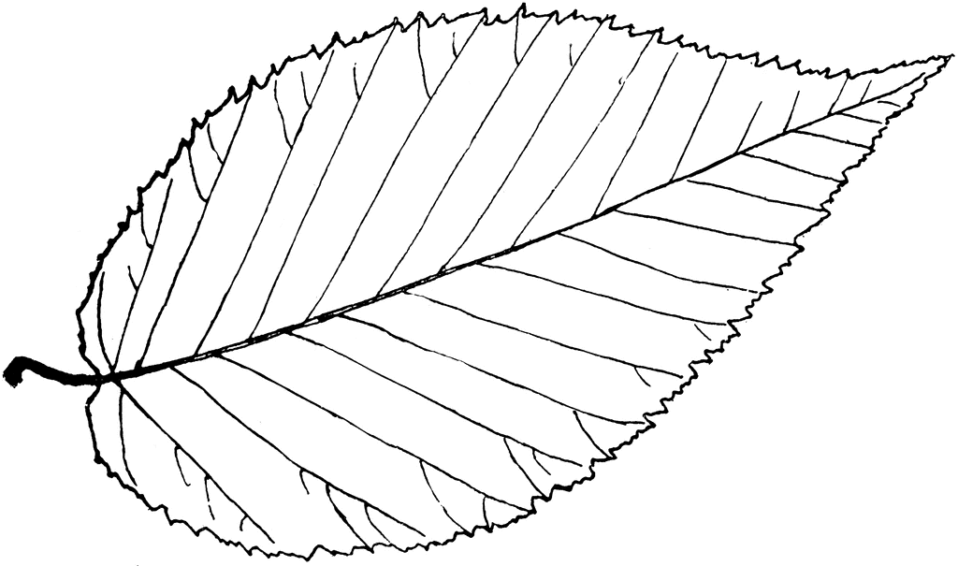

Flat, broad leaves Go to page 2.
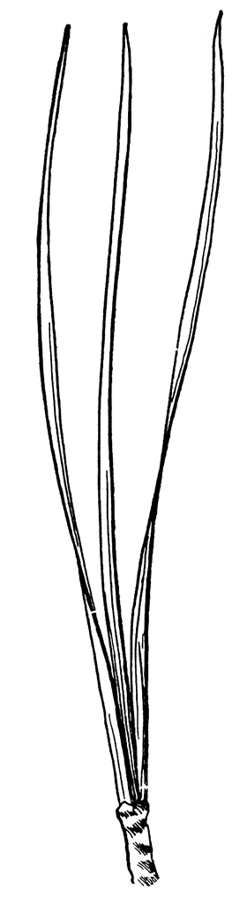
Skinny needles Go to page 3.

Leaf Dichotomous Key – Trees of Florissant, CO Page 2

Is the shape of the leaf simple (all one piece) or compound (branching into leaflets)? 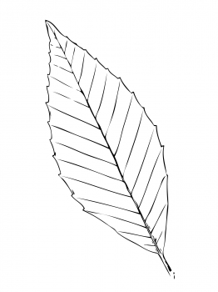

Simple Go to page 4.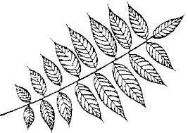
Compound Go to page 5.
Leaf Dichotomous Key – Trees of Florissant, CO Page 3

Are the needles smooth and straight, or branches covered with tiny scales?
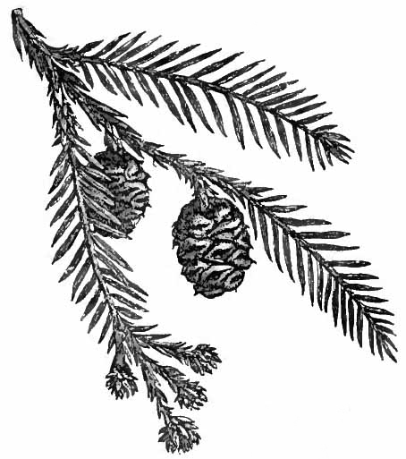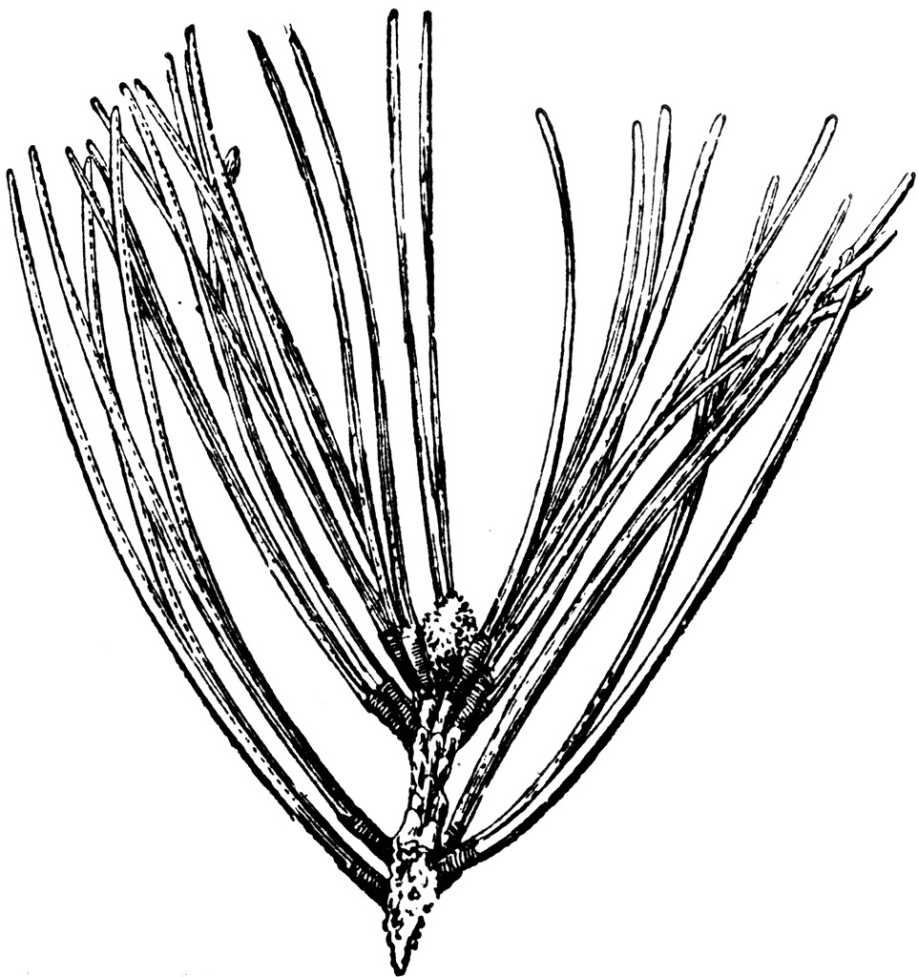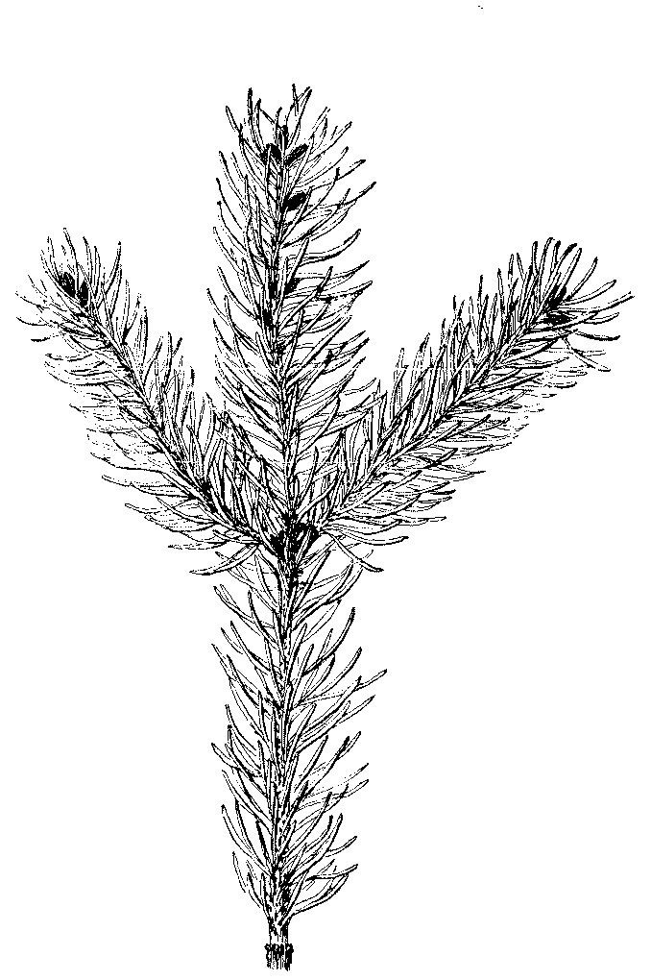
Smooth and straight Go to page 6.
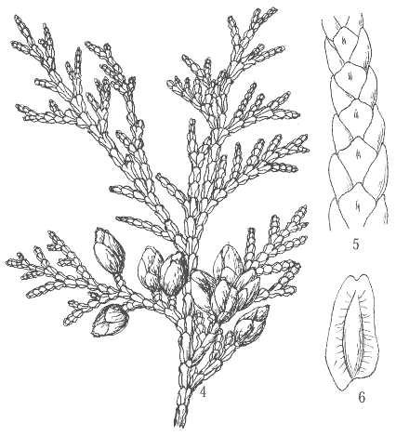
Tiny scales Your tree is a:
Cedar.
Leaf Dichotomous Key – Trees of Florissant, CO Page 4

Is the simple leaf lobed or not lobed? 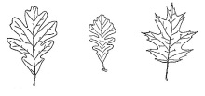 Lobed Go to page 7.
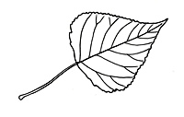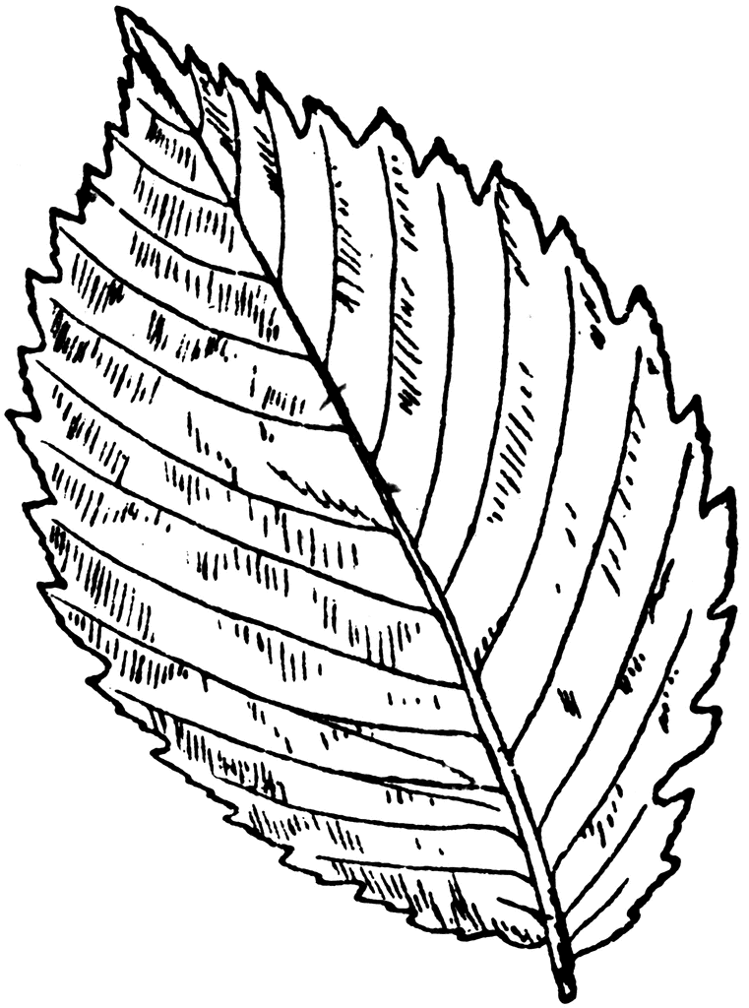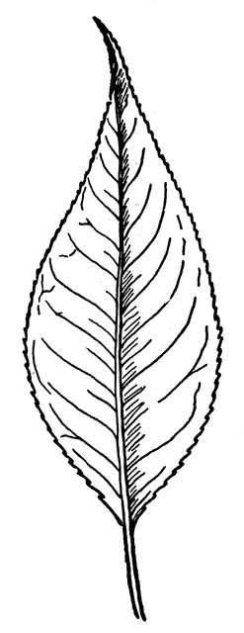
Not Lobed Go to page 8.

Leaf Dichotomous Key – Trees of Florissant, CO Page 5

Does the compound leaf have bigger leaflets on the end, or are all leaflets about the same size? 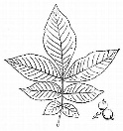
Bigger leaflets on the end Your tree is a:
Hickory.
All about the same size Your tree is a:
Walnut.
Leaf Dichotomous Key – Trees of Florissant, CO Page 6

Are the needles attached to the branch in groups, or individually (one needle at a time)?
Groups of needles Your tree is a:
Pine.
Individual needles Go to page 9.
Leaf Dichotomous Key – Trees of Florissant, CO Page 7

How many lobes (connected sections) does the leaf have?
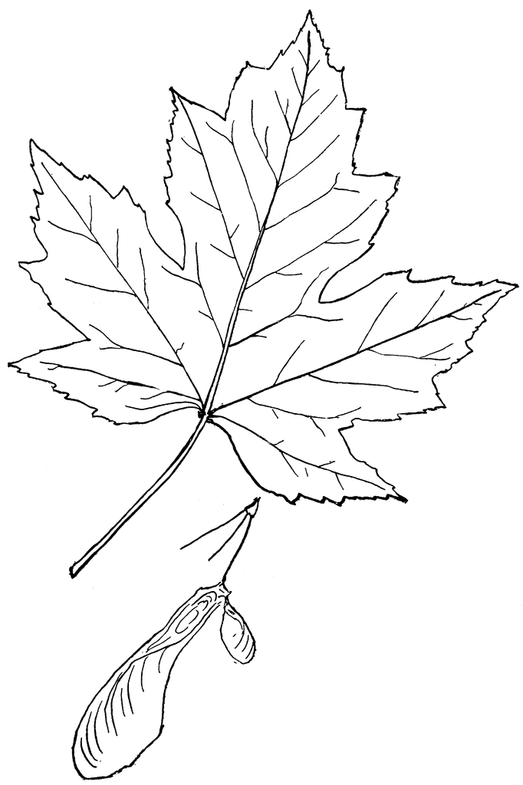
3 lobes, pointing forward Your tree is a:
Maple. 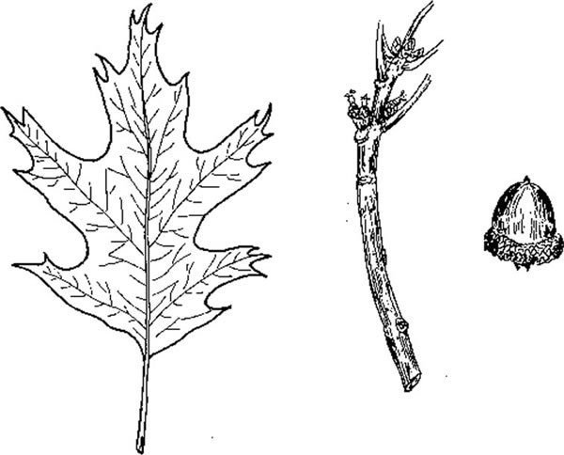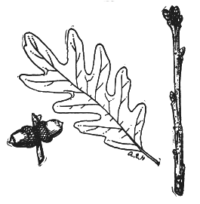

5-7 lobes, pointing out Your tree is an:
Oak.
Leaf Dichotomous Key – Trees of Florissant, CO Page 8

Does the leaf have smooth edges or toothed (jagged or bumpy) edges? 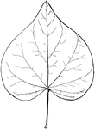
Smooth edges Go to page 10.

Toothed edges Go to page 11.

Leaf Dichotomous Key – Trees of Florissant, CO Page 9

Are the needles very short, or medium-length? 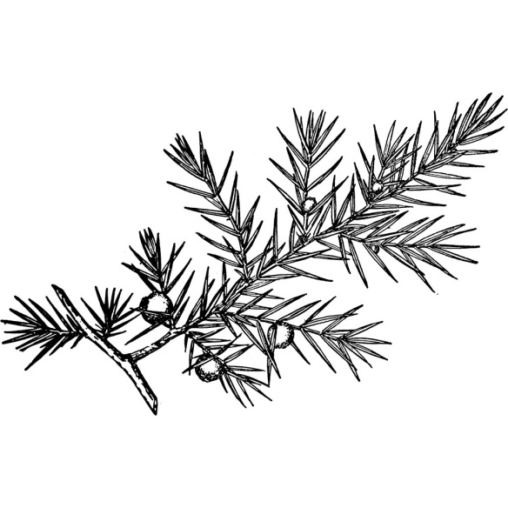
Very short needles Go to page 12.
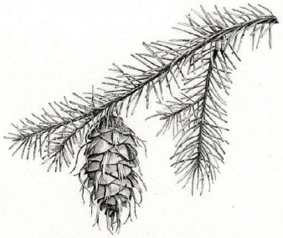
Medium-length needles Go to page 13.

Leaf Dichotomous Key – Trees of Florissant, CO Page 10

Is the shape of the leaf short and rounded, or long and narrow?
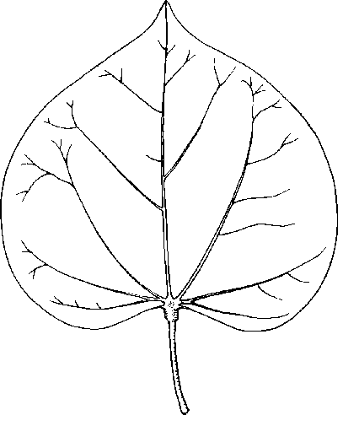
Short, rounded leaf Your tree is a:
Redbud.
Long, narrow leaf Go to page 14.

Leaf Dichotomous Key – Trees of Florissant, CO Page 11

Are the veins inside the leaf very straight and do not branch, or slightly curved and branching?
Straight, do not branch Go to page 15.
Curved, and do branch Go to page 16.
Leaf Dichotomous Key – Trees of Florissant, CO Page 12

Does the tree have feathery needles and small cones, or sharp needles and berries?
Feathery needles, cones Your tree is a:
Redwood.
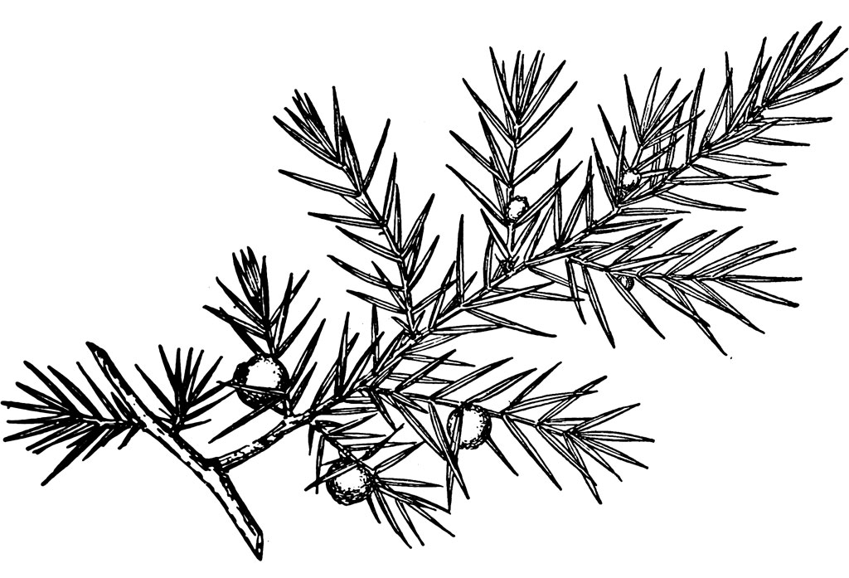
Sharp needles, berries Your tree is a:
Juniper.
Leaf Dichotomous Key – Trees of Florissant, CO Page 13

Does the tree have soft needles and cones with bracts (fancy frills on the cone), or stiff needles and cones without bracts?
Soft needles, bracts Your tree is a:
Fir.
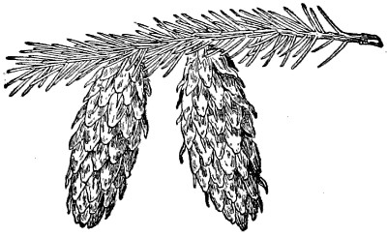
Stiff needles, no bracts Your tree is a:
Spruce.
Leaf Dichotomous Key – Trees of Florissant, CO Page 14

Is the shape of the leaf straight (about the same width along its entire length), or tapered (wide at the base and narrow near the tip)? 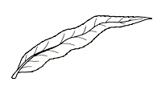
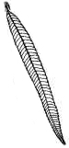
Straight Your tree is a:
Willow.
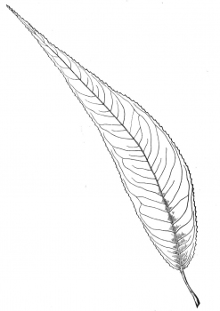
Tapered Your tree is a:
Poplar.
Leaf Dichotomous Key – Trees of Florissant, CO Page 15

Does the leaf have finely-toothed edges (many small, sharp points), or large round-toothed edges (larger, rounded bulges)? 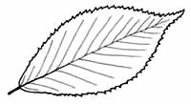
Finely-toothed edges Your tree is a:
Hornbeam.
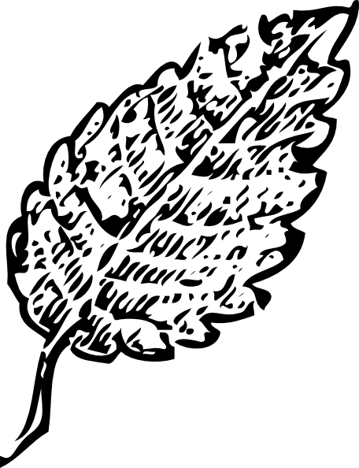
Round-toothed edges Your tree is a:
Beech
(Extinct relative).
Leaf Dichotomous Key – Trees of Florissant, CO Page 16

Is the shape of the leaf short and rounded, or long and tapered (wide near the base and narrow near the tip)?
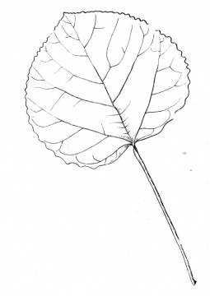
Short and rounded Your tree is an:
Aspen.
Long and tapered Your tree is an:
Elm.

